We want to share with you how we address an interior design project presenting you the main steps:
- Firstly, after meeting and speaking to our clients, we compose a Mood board in order to start a vision based on the meeting feedback. We measure the space, create a plan solution and propose a mood for the spaces using relevant suggestive images, colours and textures.
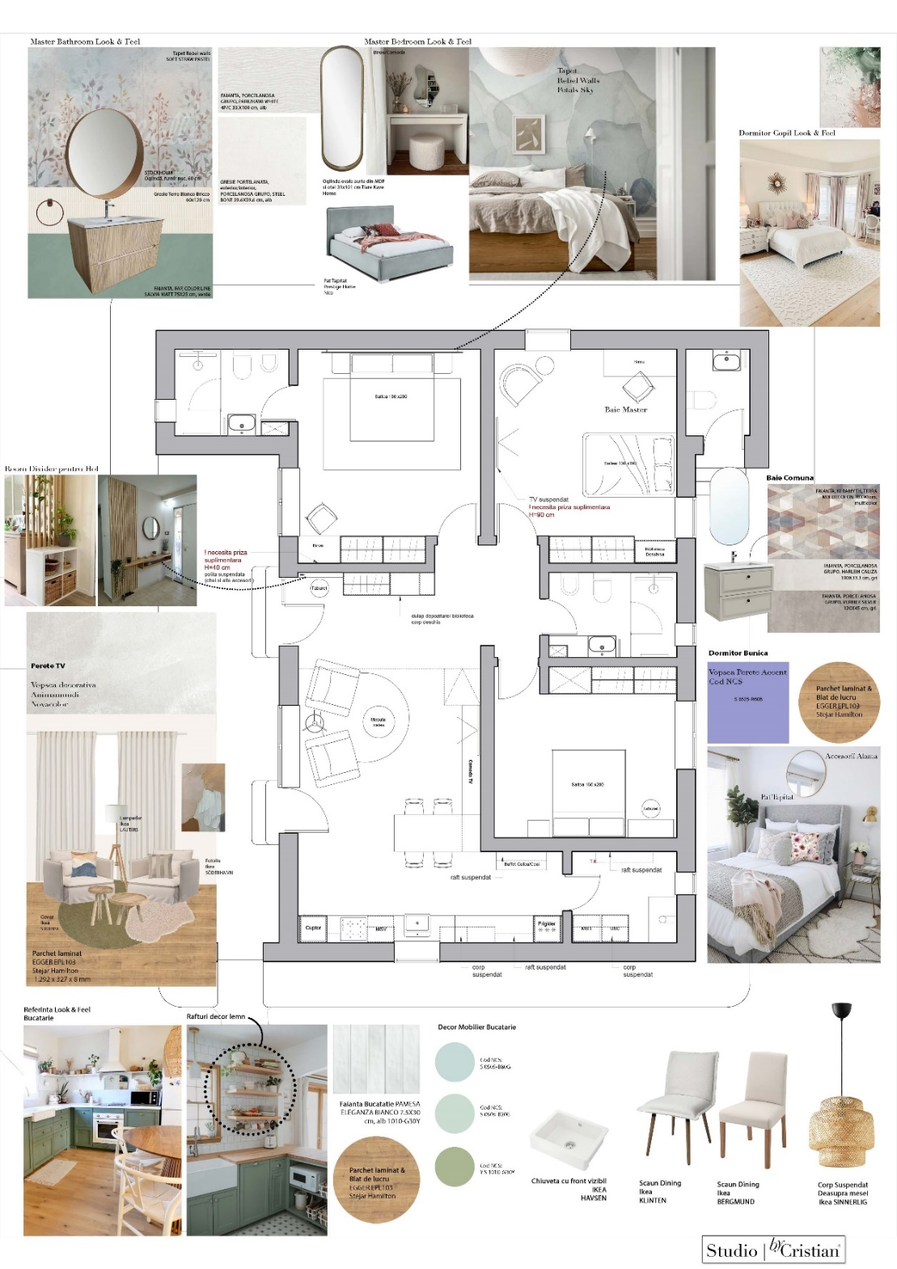
- 3D Concept
Based on the information gathered, we start tailoring the aesthetic of the space with the help of 3D visualizations.
We utilise 3D visualisations as a tool in the design process, not a destination. Flexibility is required as the project may meet variations during the implementation process.
The beneficiaries wished for a luminous open space, with wood elements, a touch of classic in the form of milled doors and custom décor from the Romanian Brancovenesc style.

Livingroom
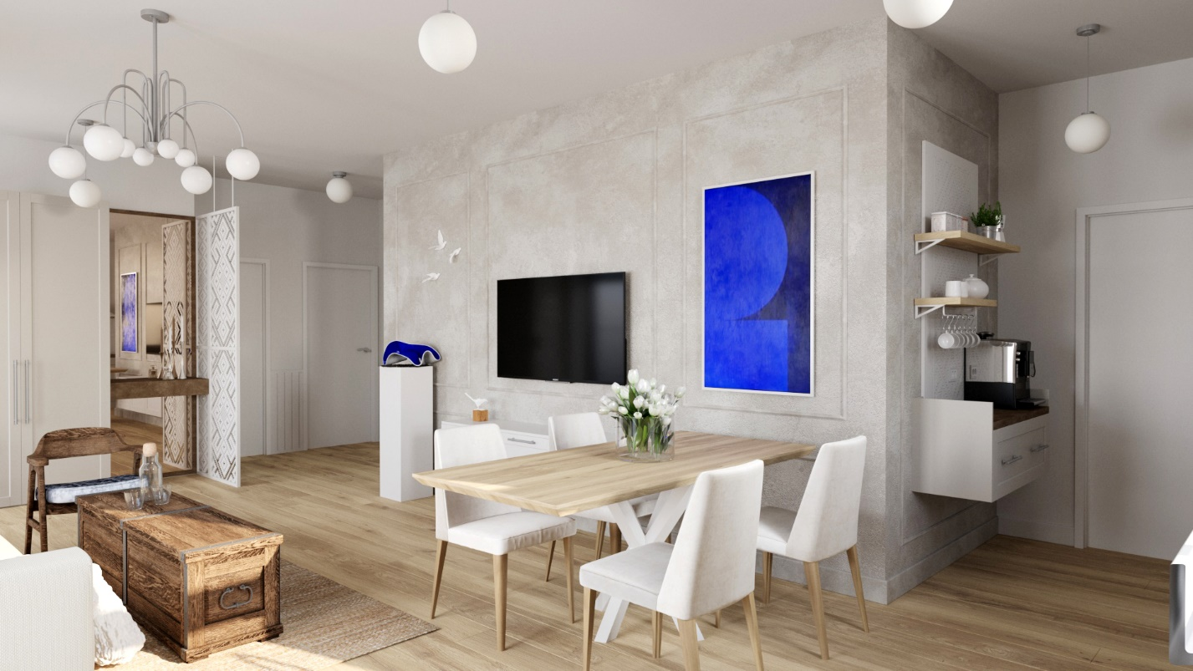

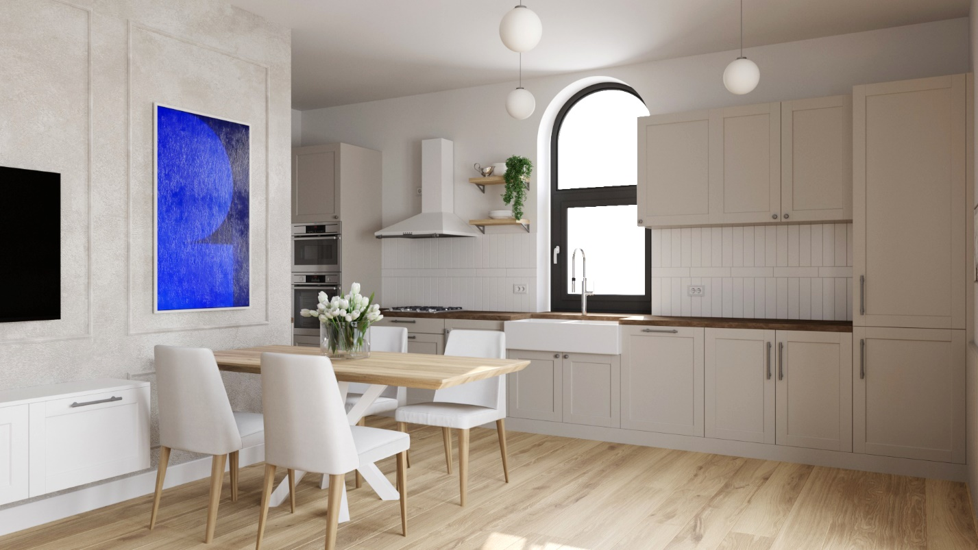

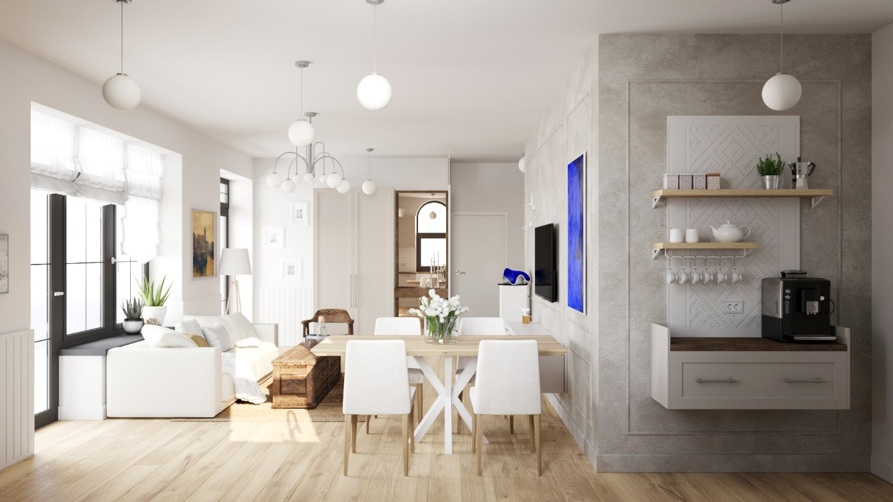

Master Bedroom & Bathroom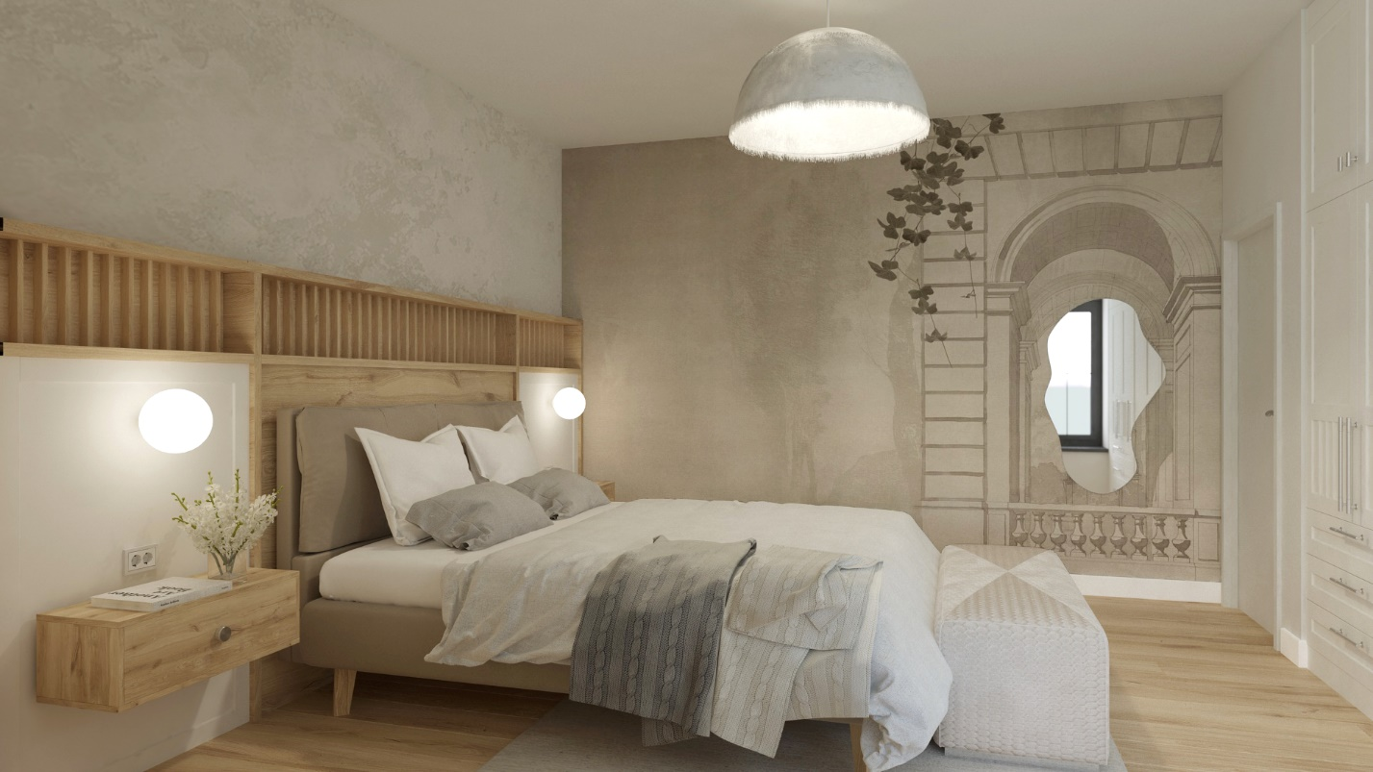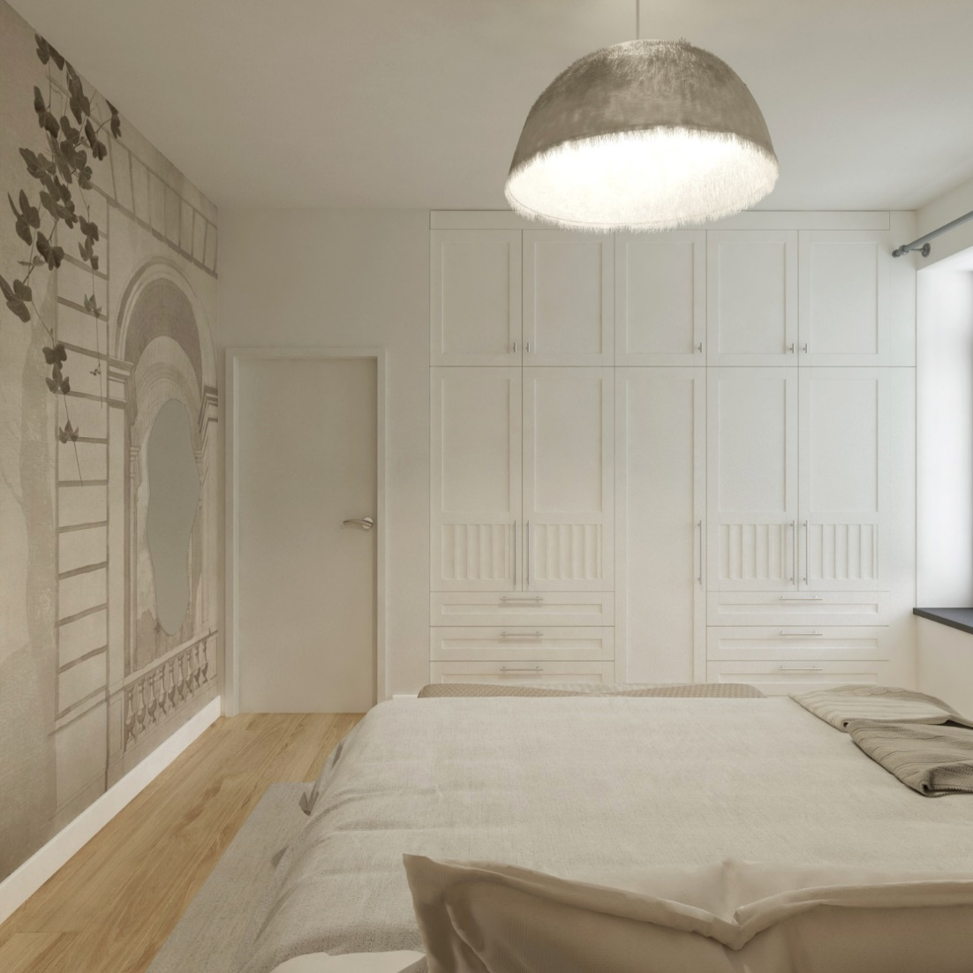

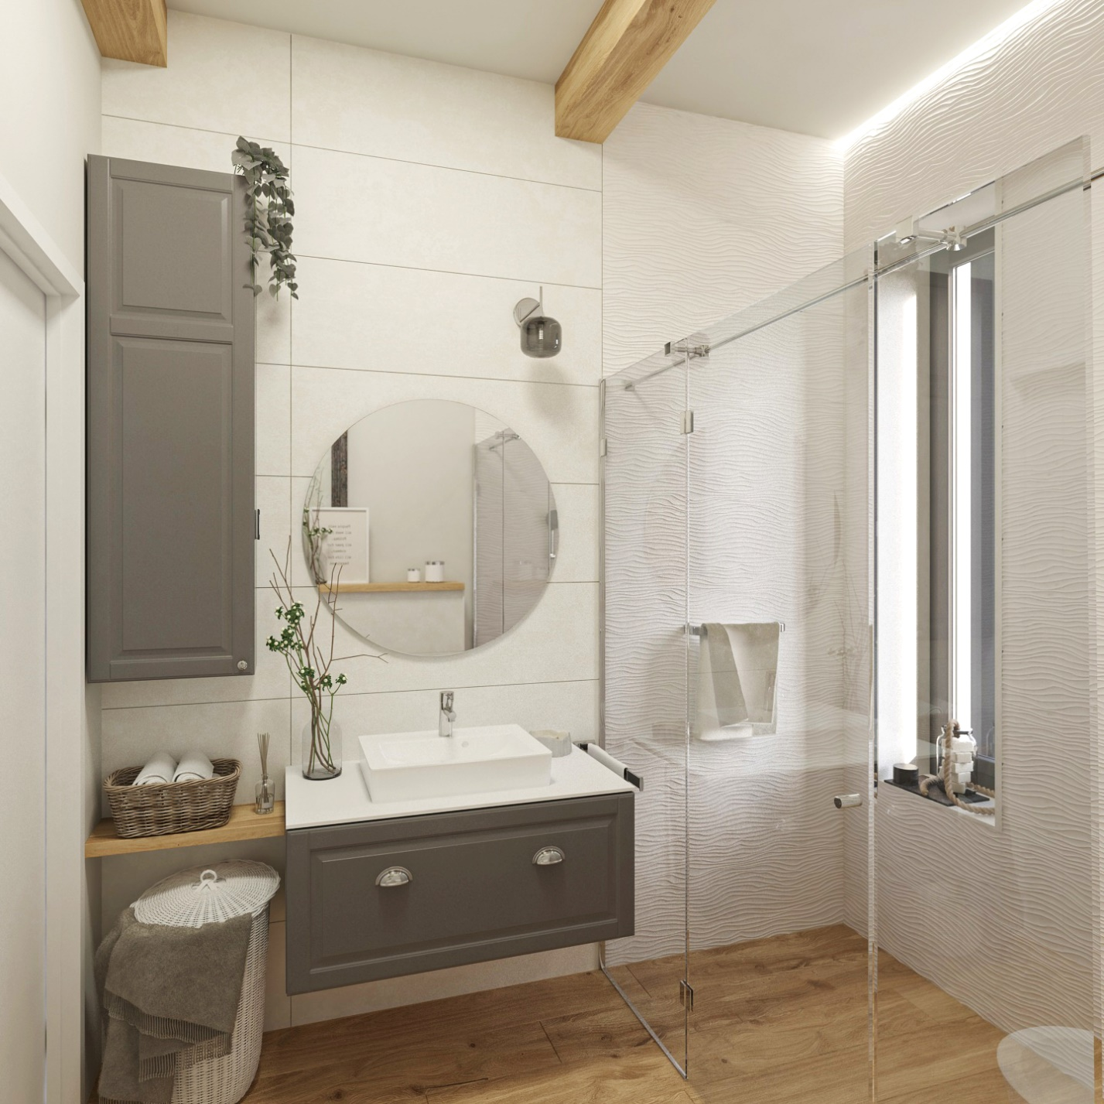

Daughter’s Bedroom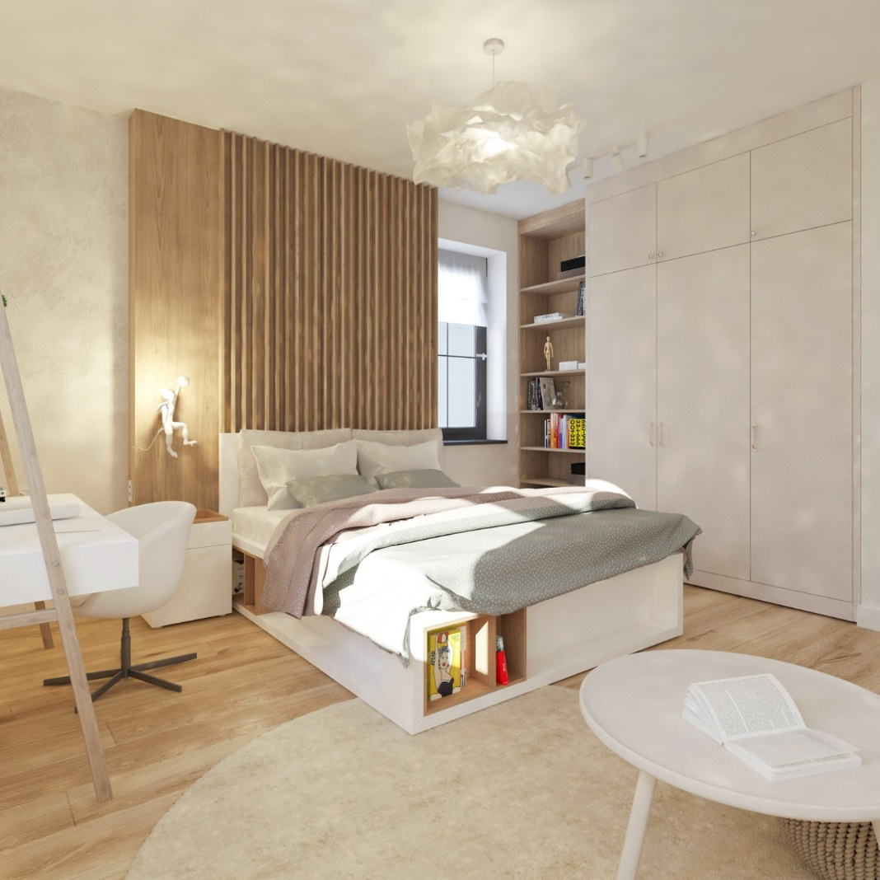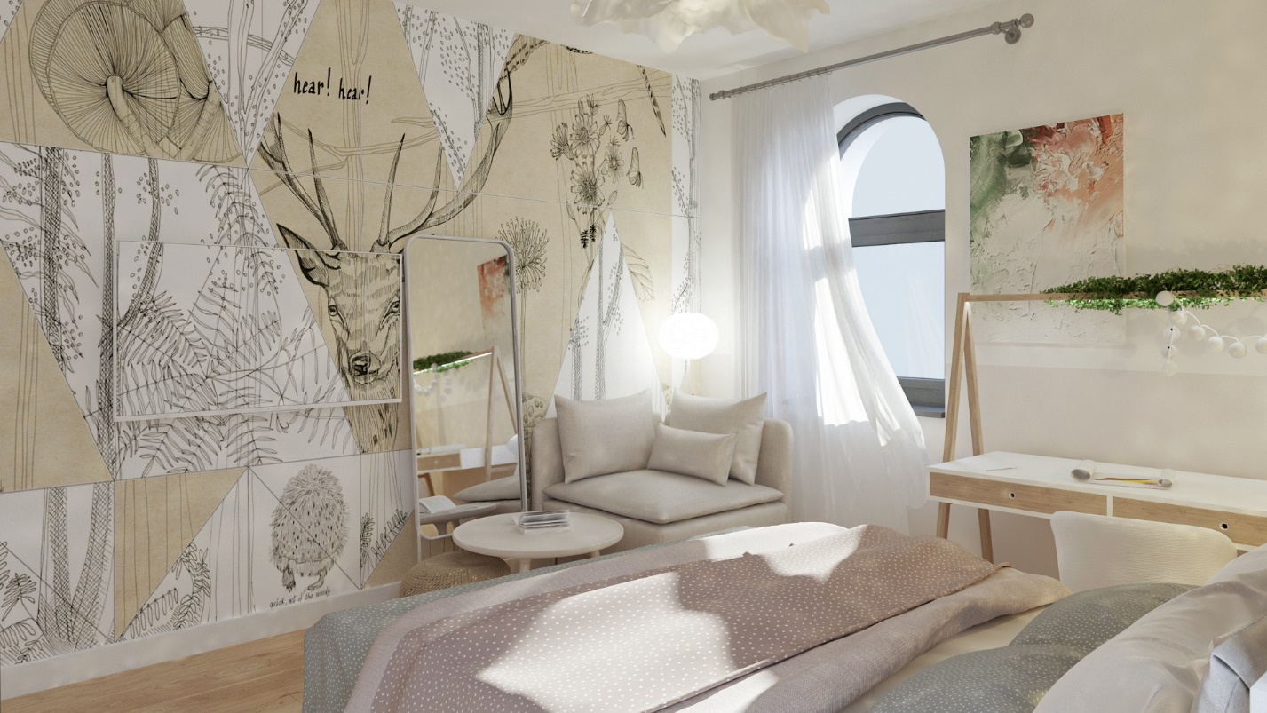
Grandmother’s Bedroom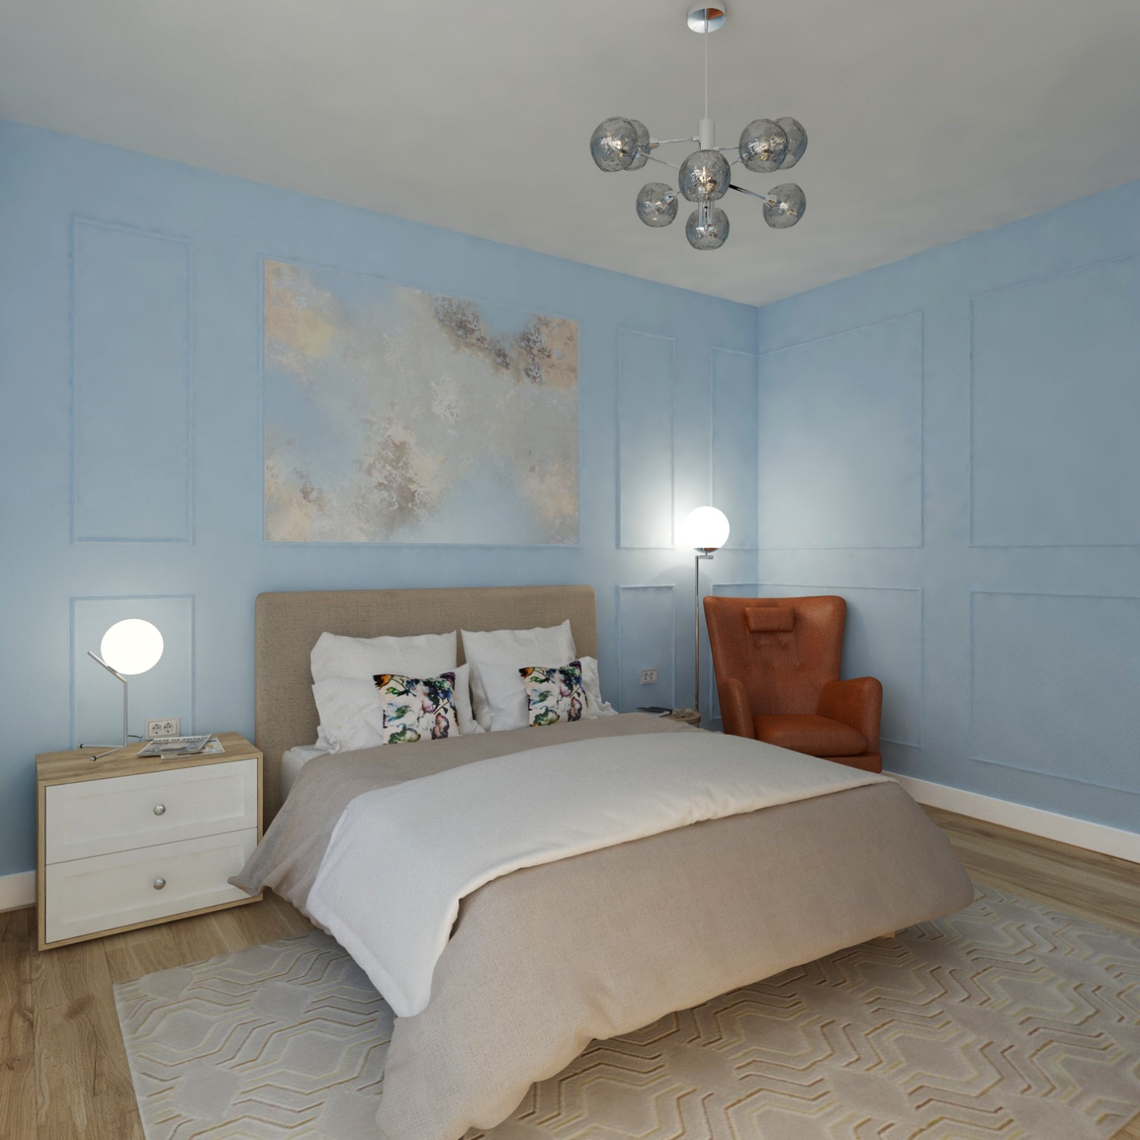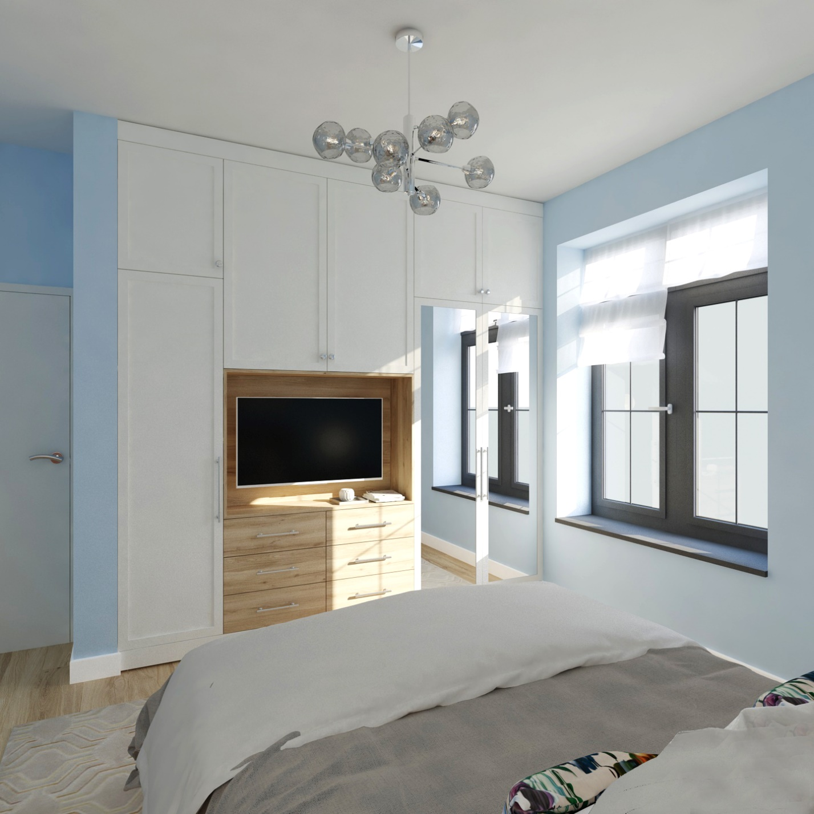

Common Bathroom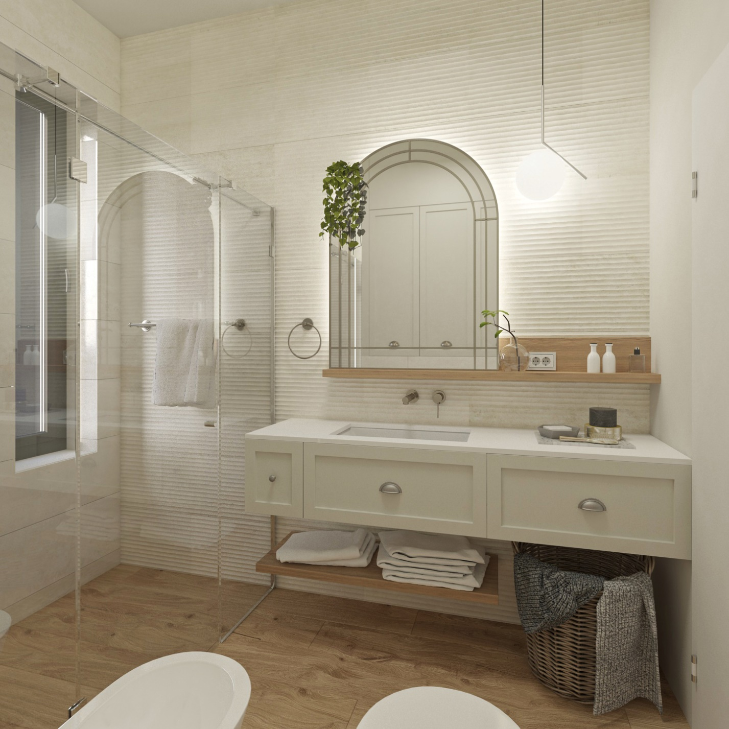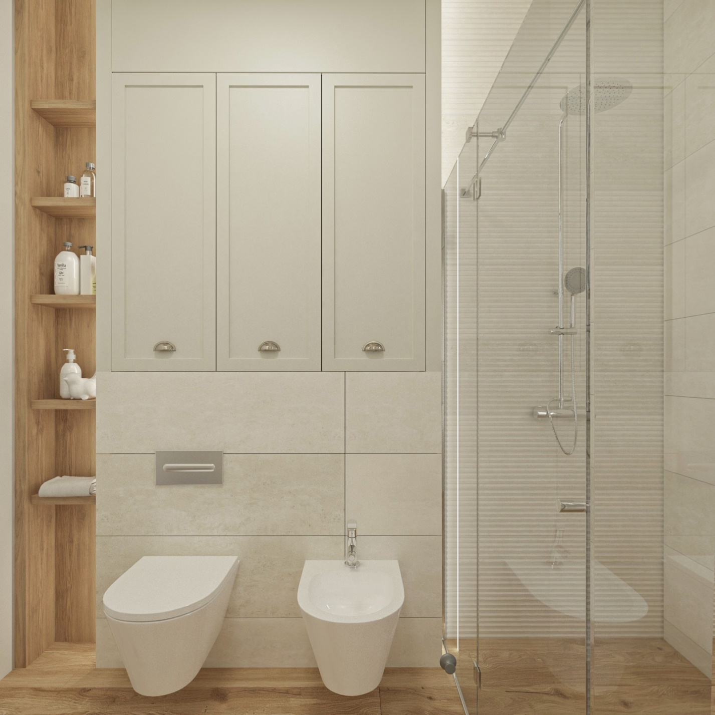

- Plan updates
We adapt the 3D concept to the house plan, synchronising every element. The plumbing, light fixtures and furniture are settled in a well-balanced composition.
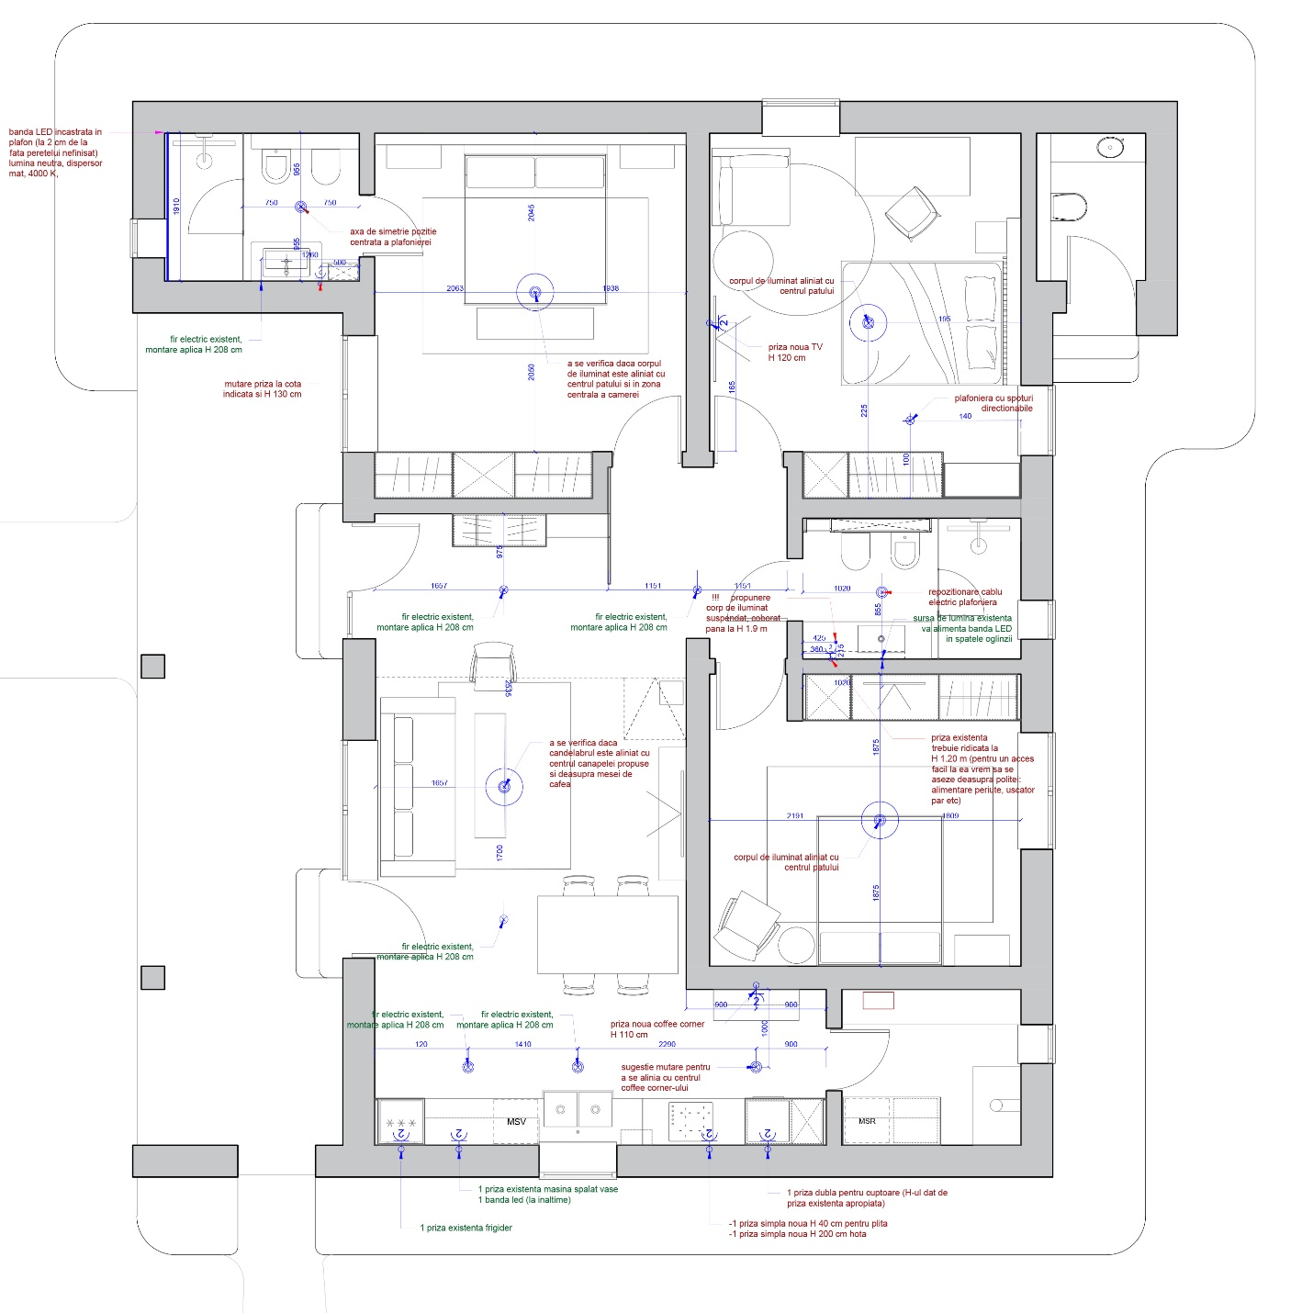

- Technical Drawings

The proposed custom furniture or décor items are being detailed in a technical sheet, ready for execution.
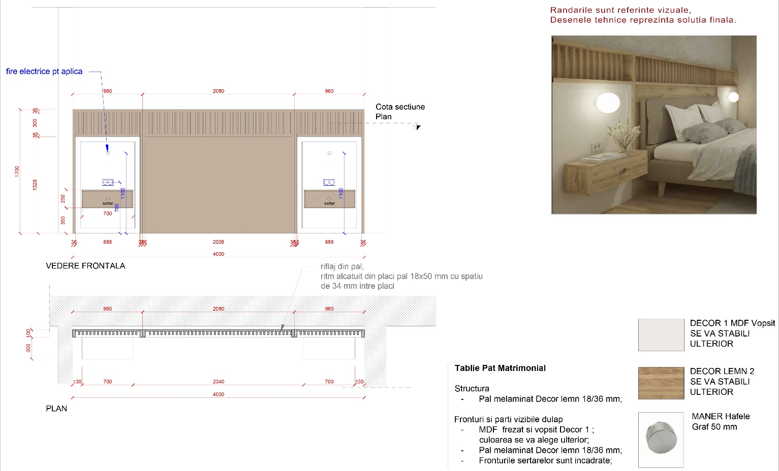

- Purchase list and price offers from suppliers

At the end of the interior design project, our clients receive all the information they need to create their dream spaces.
Clients can also choose to address our implementation project offer, which is separate from the design phase.

